EXP 25 Write the python program to implement Feed forward neural Network.
AIM:
To write and implement a Python program to create a Feed Forward Neural Network (FFNN) using TensorFlow and Keras to train the model and predict the output based on the given input data.
Program:
import tensorflow as tf
from tensorflow import keras
from tensorflow.keras import layers
import numpy as np

# Input data (XOR problem)
X = np.array([[0,0], [0,1], [1,0], [1,1]])
Y = np.array([[0], [1], [1], [0]])

# Create Feed Forward Neural Network
model = keras.Sequential([
layers.Dense(4, activation='relu', input_shape=(2,)),
layers.Dense(1, activation='sigmoid')
])

# Compile the model
model.compile(
optimizer='adam',
loss='binary_crossentropy',
metrics=['accuracy']
)

# Train the model
model.fit(X, Y, epochs=1000, verbose=0)

# Test the model
predictions = model.predict(X)

print("Predicted Output:")
print(np.round(predictions))
Output:
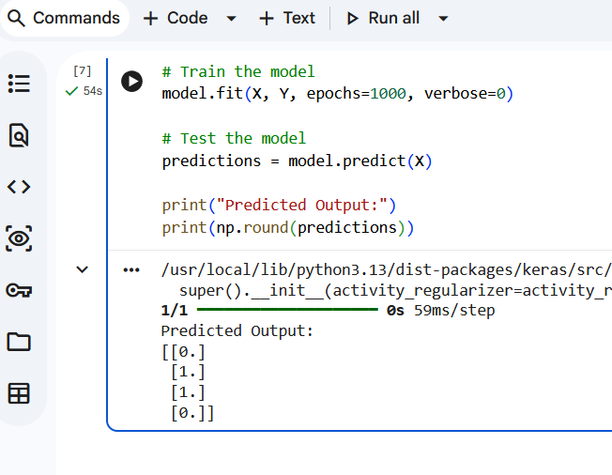
EXP 26 Write a Prolog Program to Sum the Integers from 1 to n.
AIM:
To write and implement a Prolog program to calculate the sum of integers from 1 to N using recursion.
Program:
prolog_code = """
sum(0, 0).

sum(N, S) :-
N > 0,
N1 is N - 1,
sum(N1, S1),
S is N + S1.
"""

with open("sum.pl", "w") as f:
f.write(prolog_code)

!swipl -s sum.pl -g "sum(5, S), write('Sum = '), writeln(S), halt."
Output:
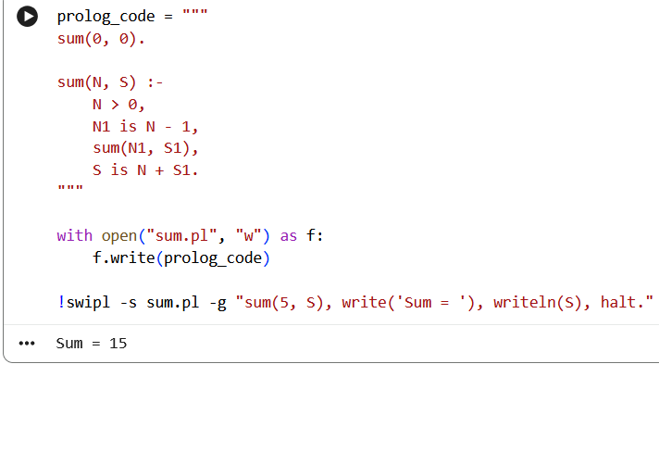
EXP 27 Write a Prolog Program for A DB WITH NAME, DOB.
AIM
To write and implement a Prolog program to create a database containing Name and Date of Birth (DOB) and retrieve and display the stored records.
Program:
prolog_code = """
person('Arun', '2002-05-10').
person('Priya', '2003-08-15').
person('Kumar', '2001-12-20').
person('Divya', '2002-03-25').

display :-
person(Name, DOB),
write('Name: '), write(Name),
write(', DOB: '), write(DOB), nl,
fail.

display.
"""

with open("database.pl", "w") as f:
f.write(prolog_code)

!swipl -s database.pl -g "display, halt."
Output:
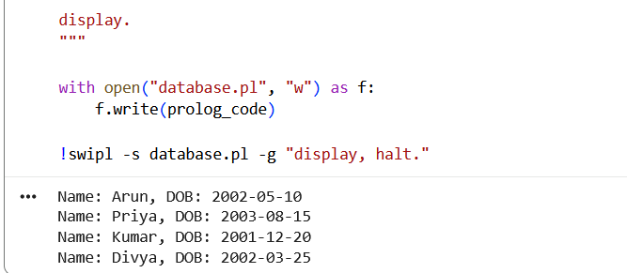
EXP 28 : Write a Prolog Program for STUDENT TEACHER-SUB-CODE.
AIM
To write and implement a Prolog program to create a database containing Student Name, Teacher Name, and Subject Code and retrieve and display the stored records.
Program:
prolog_code = """
student_teacher('Arun', 'Ramesh', 'CS101').
student_teacher('Priya', 'Kumar', 'CS102').
student_teacher('Divya', 'Suresh', 'CS103').
student_teacher('Rahul', 'Anitha', 'CS104').

display :-
student_teacher(Student, Teacher, SubCode),
write('Student: '), write(Student),
write(', Teacher: '), write(Teacher),
write(', Subject Code: '), write(SubCode), nl,
fail.

display.
"""

with open("student.pl", "w") as f:
f.write(prolog_code)

!swipl -s student.pl -g "display, halt."
Output:
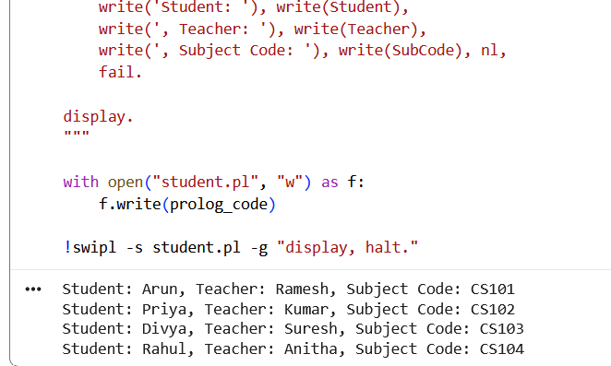

EXP 29: Write a Prolog Program for PLANETS DB.
AIM
To write and implement a Prolog program to create a Planet Database (PLANETS DB) and retrieve and display the details of different planets.
Program:
prolog_code = """
planet(mercury, 4879, terrestrial).
planet(venus, 12104, terrestrial).
planet(earth, 12742, terrestrial).
planet(mars, 6779, terrestrial).
planet(jupiter, 139820, gas_giant).
planet(saturn, 116460, gas_giant).
planet(uranus, 50724, ice_giant).
planet(neptune, 49244, ice_giant).

display :-
planet(Name, Diameter, Type),
write('Planet: '), write(Name),
write(', Diameter (km): '), write(Diameter),
write(', Type: '), write(Type), nl,
fail.

display.
"""

with open("planets.pl", "w") as f:
f.write(prolog_code)

!swipl -s planets.pl -g "display, halt."
Output:
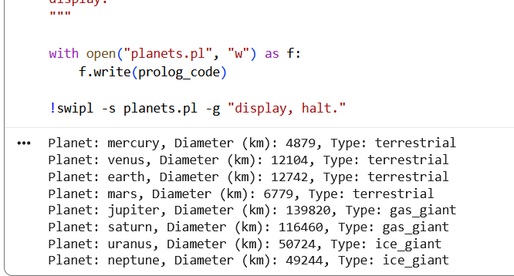

Exp 30 Write a Prolog Program to implement Towers of Hanoi.
Aim:
To write and implement a Prolog program to solve the Towers of Hanoi problem using recursion.
Program:
prolog_code = """
hanoi(1, Source, Destination, _) :-
write('Move disk from '),
write(Source),
write(' to '),
write(Destination), nl.

hanoi(N, Source, Destination, Auxiliary) :-
N > 1,
N1 is N - 1,
hanoi(N1, Source, Auxiliary, Destination),
hanoi(1, Source, Destination, Auxiliary),
hanoi(N1, Auxiliary, Destination, Source).
"""

with open("hanoi.pl", "w") as f:
f.write(prolog_code)

!swipl -s hanoi.pl -g "hanoi(3, a, c, b), halt."
Output:


